**Practical No.03**

**Aim: Programs based on control statement (if, switch)**

**1. C Program to find out the n umber is a Pythagoras triplet**

**Program:**

#include<stdio.h>

#include<conio.h>

void main()

{

//Examples of If statement

int a,b,c;

clrscr();

printf("Enter three numbers:\t");

scanf("%d%d%d",&a,&b,&c);

if(((a*a)==(b*b)+(c*c))||((b*b)==(c*c)+(a*a))||((c*c)==(a*a)+(b*b)))

{

printf("\nNumbers are Pythagorean triplates");

}

else

{

printf("\nNumbers are not pythagorean triplates");

}

getch();

}

**Output:**

Enter three numbers: 5 4 3

Numbers are Pythagorean triplets

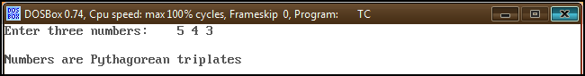

**2. C Program to Relate Two Integers using Nested If…else statement.**

**Program:**

// Program to relate two integers using =, > or <

#include<stdio.h>

#include<conio.h>

void main()

{

int number1, number2;

clrscr();

printf("Enter two integers:\t");

scanf("%d %d", &number1, &number2);

//checks if two integers are equal.

if(number1 == number2)

{

printf("Result: %d = %d",number1,number2);

}

//checks if number1 is greater than number2.

else if (number1 > number2)

{

printf("Result: %d > %d", number1, number2);

}

// if both test expression is false

else

{

printf("Result: %d < %d",number1, number2);

}

getch();

}

**Output:**

Enter two integers: 12

23

Result: 12 < 23

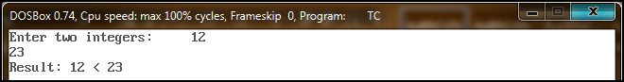

**3. C program to print days of week name using switch case**

**Program:**

//C program to print day of week using switch case

#include <stdio.h>

#include <conio.h>

void main()

{

int week;

clrscr();

//Reads week number from user

printf("Enter week number(1-7): ");

scanf("%d", &week);

switch(week)

{

case 1: printf("MONDAY");

break;

case 2: printf("TUESDAY");

break;

case 3: printf("WEDNESDAY");

break;

case 4: printf("THURSDAY");

break;

case 5: printf("FRIDAY");

break;

case 6: printf("SATURDAY");

break;

case 7: printf("SUNDAY");

break;

default: printf("Invalid input! Please enter week number between 1-7");

}

getch();

}

**Output:**

Enter week number(1-7): 1

MONDAY

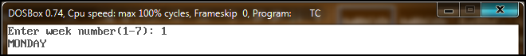

**4. C Program to Print 1 To 10 Number using goto statement**

**Program:**

//Write a C Program Which Print 1 To 10 Number Using goto statement.

#include<stdio.h>

#include<conio.h>

void main()

{

int i=1;

clrscr();

count: //This is Label

printf("%d\n",i);

i++;

if(i<11) {

goto count; //This jumps to label "count:"

}

getch();

}

**Output:**

1

2

3

4

5

6

7

8

9

10

